
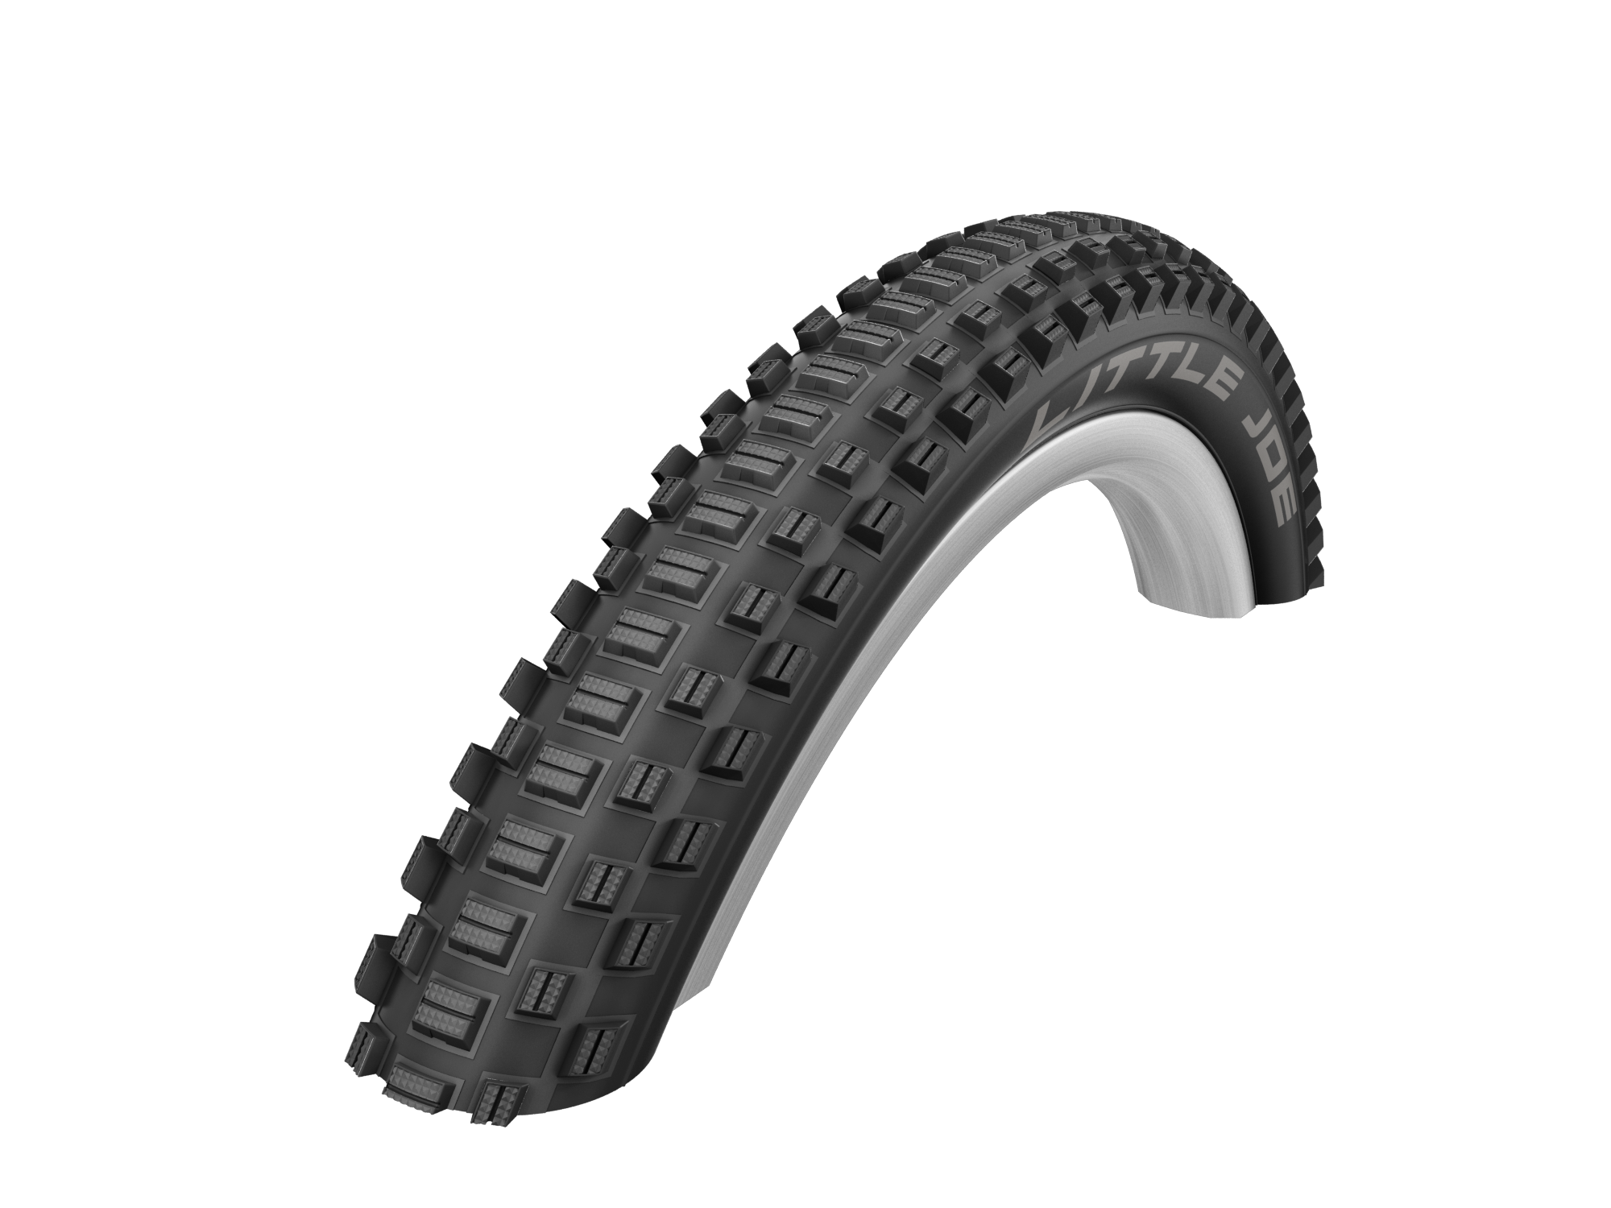
Testrider Remo (7) has gotten the hang of it. The Little Joe was especially
Photos: Schwalbe made for kid’s bikes.

Little Joe – a big hit with small bikers

For all of those who have big plans: Little Joe is Schwalbe’s first tire to have been especially developed for children’s bikes.

Kids want the cool mountain bike look. “But on the street, studded tires, which are often heavy, don’t roll so well on children’s bikes,” explains father of three and Schwalbe Marketing Manager, Carsten Zahn. The tread profile of the Little Joe is great over asphalt. With its 290 grams, it is also a genuine light weight! A good kilo in weight can be knocked off an otherwise often heavy child’s bike.
“Little Joe’s profile has already proven its worth in BMX competitions. Originally, it comes from our Mow Joe. Mow Joe was also frequently bought by dads with the purpose of tuning their children’s bikes”, reports Carsten Zahn.
Schwalbe is offering the Little Joe in a light weight, folding tire version for the classic size 20 x 2.00 (50-506) and in the extraordinary version 20 x 1.40 (37-406) – the narrower 20 inch. “Because kids are so light, this size is more than enough, and it also saves a lot of weight,” explains Carsten Zahn. Fat tires aren’t really needed for kids who usually weigh between 20 and 30 kilograms and who can therefore ride over rough terrain with narrow tires at very low pressures.
The technology used on the Little Joe comes from the Active Line, and with a K-Guard belt and 50 EPI-carcass, it is perfect for everyday use. Its reflective labels are a genuine coolness factor for young bikers. Small but great, Little Joe was named after the cult TV show, Bonanza.
Little Joe tires will be available in the specialized trade in Spring 2016. Price: 24,90 euro.

This press release with photos and Graphics can be downloaded from: www.schwalbe.com/en/presse.html

SCHWALBE - Ralf Bohle GmbH  Doris Klytta
Otto-Hahn-Straße 1  51580 Reichshof-Wehnrath
Telefon: +49 2265 109-57  Fax: +49 2265 7022
d.klytta@schwalbe.com  www.schwalbe.com

